UX and UI

Considerations for Mobile Game Development

UX

1. Rapidly Iterate & Prototype - Make it interactive as fast as possible.

* Get something working as fast as possible, use place holder graphics if necessary
* Does the flow between screens make logical sense?
* Are the fonts readable?
* How large are the buttons? Are they suitable for touch interface?

2. Ensure Continuity and Consistency – Make sure everything works together.

* Consistency across all game screens and functions
* Buttons should all have the same look and feel
* Button functions should be consistent, for example a Back/Close/Cancel button should always be represented by the sane icon & colour e.g. Red X and Accept should always be the same e.g. Green Tick. These shouldn’t be mix/matched with say Yes / No instead.
* Colours - Use Colour in a consistent and meaningful way, not just to look good.
  + It’s really important we use colours correctly in our interface for anything that needs to have important logic behind it. The use of reds, greens, and other standard colours has certain preconceived meanings to people which we must be aware of.

3. Use Icons - Use graphics whenever possible or keep graphics minimalistic.

1. Utilizing a more iconographic approach to interface design is clearer and sexier. Using icons will allow you to show something small (the icon) instead of a LOT of text and can make it a lot cleaner for players.
2. To make certain sections more understandable (initial game instructions), all text or mostly text only approach could be used

More stuff here: <https://developer.apple.com/ios/human-interface-guidelines/icons-and-images/app-icon/>

<https://developer.apple.com/ios/human-interface-guidelines/visual-design/adaptivity-and-layout/>

4. Make the Game Make Sense

Players need to understand why things happen in the game in order to feel that they’re in control. In game design, a sensible experience relies on some mutual understanding between the designer and the player:

* When the player loses, the reason they lost should be clear. If it’s not, then the player won’t be able to get better at the game by avoiding the same mistake in future.
* When the player wins, the reason they won should be clear. If not, then replicating the victory will be hard.
* Every effect should have a clear cause. When something happens, the player should be able to see why it happened.
* The object of the game should be clear. The player needs to know what they’re working toward.
* The player should always know what actions may be performed. At every moment, visible or aural cues should be provided to let the player know what they can do.

Playtest - Test on mobile devices and tablets.

* Test the interface on multiple devices of various sizes.
* Test them on smaller phones or min spec devices.
* Otherwise we may find the buttons are too small or fonts being too hard to read.
* What are the most common screen resolutions / screen sizes? Viewport Size?

|  |  |  |
| --- | --- | --- |
|  | **Pixel Size** | **Viewport** |
| **iPhone** |  |  |
| iPhone X | 1125 x 2436 | 375 x 812 |
| iPhone 8 Plus | 1080 x 1920 | 414 x 736 |
| iPhone 8 | 750 x 1334 | 375 x 667 |
| iPhone 7 Plus | 1080 x 1920 | 414 x 736 |
| iPhone 7 | 750 x 1334 | 375 x 667 |
| iPhone 6 Plus/6S Plus | 1080 x 1920 | 414 x 736 |
| iPhone 6/6S | 750 x 1334 | 375 x 667 |
| iPHone 5 | 640 x 1136 | 320 x 568 |
| **iPod** |  |  |
| iPod Touch | 640 x 1136 | 320 x 568 |
| **iPad** |  |  |
| iPad Pro | 2048 x 2732 | 1024 x 1366 |
| iPad Third & Fourth Generation | 1536 x 2048 | 768 x 1024 |
| iPad Air 1 & 2 | 1536 x 2048 | 768 x 1024 |
| iPad Mini | 768 x 1024 | 768 x 1024 |
| iPad Mini 2 & 3 | 1536 x 2048 | 768 x 1024 |

|  |  |  |
| --- | --- | --- |
|  | **Pixel Size** | **Viewport** |
| **Phones** |  |  |
| Nexus 6P | 1440 x 2560 | 411 x 731 |
| Nexus 5X | 1080 x 1920 | 411 x 731 |
| Google Pixel | 1080 x 1920 | 411 x 731 |
| Google Pixel XL | 1440 x 2560 | 411 x 731 |
| Google Pixel 2 | 1080 x 1920 | 411 x 731 |
| Google Pixel 2 XL | 1440 x 2560 | 411 x 731 |
| Samsung Galaxy Note 5 | 1440 x 2560 | 480 x 853 |
| LG G5 | 1440 x 2560 | 480 x 853 |
| One Plus 3 | 1080 x 1920 | 480 x 853 |
| Samsung Galaxy S8 | 1440 x 2960 | 360 x 740 |
| Samsung Galaxy S8+ | 1440 x 2960 | 360 x 740 |
| Samsung Galaxy S7 | 1440 x 2560 | 360 x 640 |
| Samsung Galaxy S7 Edge | 1440 x 2560 | 360 x 640 |
| **Tablets** |  |  |
| Nexus 7 (2013) | 1200 x 1920 | 600 x 960 |
| Nexus 9 | 1536 x 2048 | 768 x 1024 |
| Samsung Galaxy Tab 10 | 800 x 1280 | 800 x 1280 |
| Chromebook Pixel | 2560 x 1700 | 1280 x 850 |

User interface game prototypes

Symmetric Layout – Considering hands and orientation

Layout 1

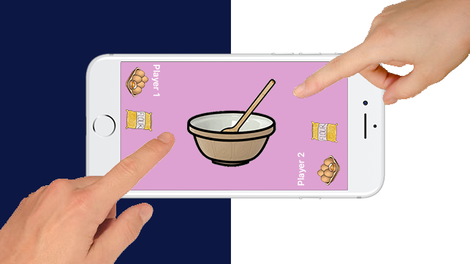

Layout 2

